FEMM Magnetostatics Lab
Seth Ricks
Brother Swenson
11/7/2025

ECEN 390 - FEMM Magnetostatics Lab (50 points)
(jas, FEMM Magnetostatics Lab.docx, 11/05/2025)

Note: This is a CAD lab to be done individually, rather than in teams, although please help each other out if/when opportunities arise, avoiding plagiarism. Submit an electronic version of a lab report to receive credit for doing this lab. The goal of your lab report is to provide sufficient documentation so that others could re-create your results. Therefore, simply add to this document to arrive at your lab report, as all of the explanatory text, procedures and Discussion and Conclusion questions contained in this document are required for a complete lab report. So, for your lab report, add a cover page, your results, along with your answers to the Discussion and Conclusions questions to the existing lab document. Your answers to the Discussion and Conclusions questions are to be uniquely yours and not a copy of someone else’s answers to these questions. Your cover page is to include class, lab title, and author. A grading rubric for this lab is included at the end of this document. The rubric does not need to be included in your lab report.

Purpose: The purpose of this lab is to better understand both FEMM (Finite Element Method Magnetics) and magnetostatics by analyzing two magnetostatic problems.

Procedure:

Part 1 – Two Adjacent Conductors

- In FEMM open of File New Magnetostatics Problem, resulting in the Magnetostatics Model Development Window.
- Select Problem on the top toolbar to open the Problem Definition dialog box and verify/complete the following settings: Problem Type: Planar, Length Units: Millimeters, Depth: 1000, corresponding to 1 m.
- Select Properties Materials to open the Property Definition dialog box. Click on the Add Property with a Name of Wire, having relative permeability μ_{x} and μ_{y} values of 1.
- Click on Add Property a gain with a Name of Air, also having relative permeability μ_{x} and μ_{y} values of 1.
- Select the Point (node) drawing mode. The tab key provides an easy way to exactly locate points (nodes) via numeric entry of the x and y coordinates.
- Enter the following x-y point coordinates using the tab key: (-1.25, 0), (-0.25, 0), (-0.75, 0.5), (-0.75, -0.5), (0.25, 0), (1.25, 0), (0.75, 0.5), (0.75, -0.5). The points entered form the outlines of two parallel wires.
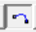
- Select Arc drawing mode.
- Traversing the points on each wire in a Counter-Clockwise direction, left mouse click on one point (node) then on the next point (node) to open the Arc segment properties dialog box. Set/verify the Arc Angle of 90˚, which is the angle traversed from the center of the circle from the first selected point (node) to the next. Join Arc Segments between points (nodes) to produce a 2-D cross section of two parallel wires as illustrated below in Figure 1.
- Select the Point (node) drawing mode. Enter the following x-y point coordinate using the tab key: (0, 0), and (0, 7.5). These points (nodes) are to be used as a contour endpoints in the upcoming analysis of the parallel conductors.
- Add a Boundary around the wires by clicking on the Boundary icon. In the Open Boundary Builder dialog box set the Layers to 3 and a Radius of 8. Also set/verify the Horizontal and Vertical Center coordinates (0, 0).
- Select the block drawing mode and then left mouse click inside each wire and in the area outside the wires and inside the boundary to include block labels. Then right mouse click on each block label to select it, followed by pressing the keyboard space bar to open the Properties for selected block dialog box to assign the appropriate predefined material label, i.e., Wire and Air to each block label shown below in Figure 1.
- Select Properties Circuits to open the Property Definition dialog box. Click on Add Property and include a property name of Left Wire, followed by selecting a Series circuit and setting the Circuit Current, Amps of 1.0.
- Again select Properties Circuits to open the Property Definition dialog box. Click on Add Property and include a property name of Right Wire, followed by selecting a Series circuit and setting the Circuit Current, Amps of -1.0.
- In the block drawing mode select the Wire block label for the left wire. Press the spacebar to open the Properties for selected block dialog box and in the In Circuit box select Left Wire. Repeat this procedure for the Right Wire, resulting in the geometric model illustrated below in Figure 1. Save your results, which produces a file with the FEM file extension for a Magnetostatics problem.
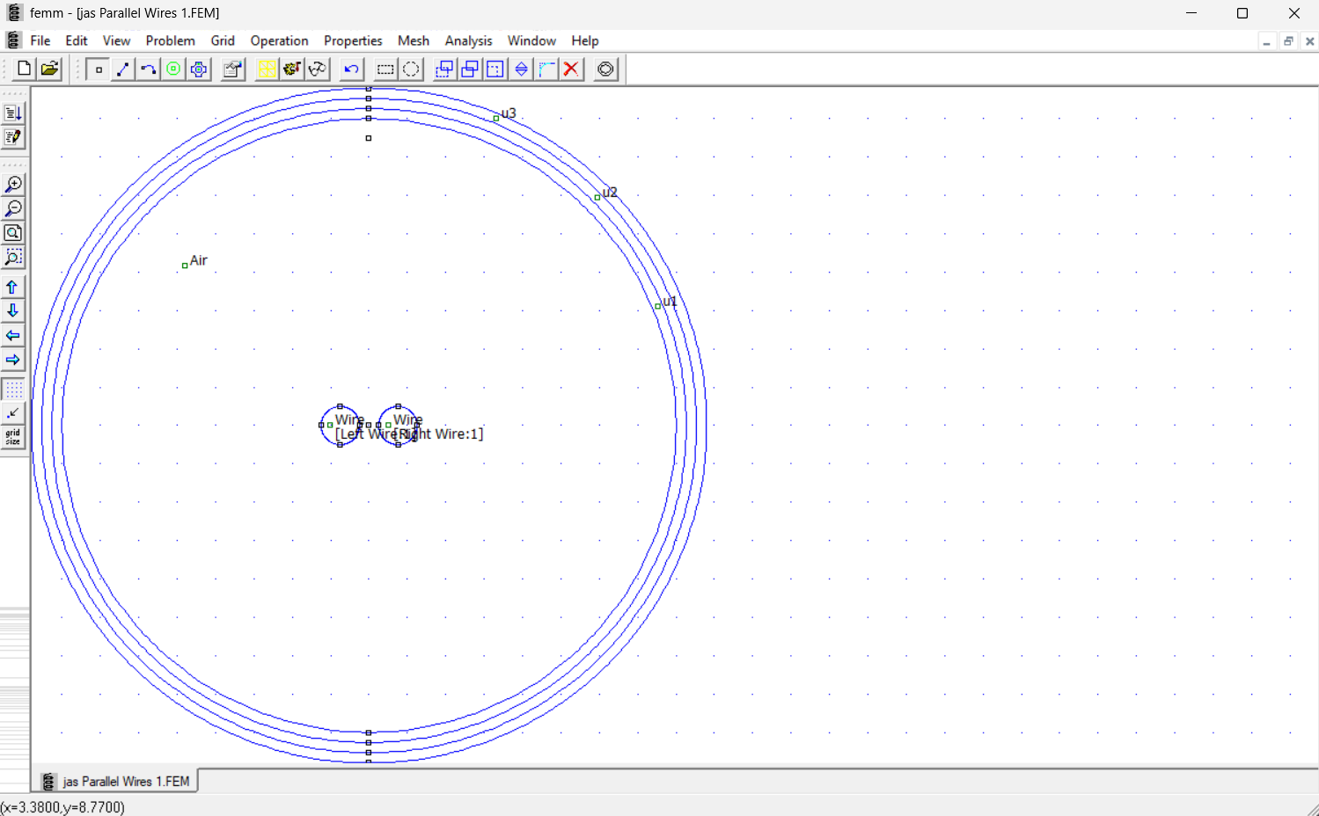
Figure 1: Geometry Window for Two Adjacent Conductors.
- Select Mesh Create Mesh, followed by solving the problem followed by Analysis Analyze, and Analysis View Results. Creating the mesh and analyzing the problem and viewing the results can also be accomplished by the icons. (Note: Inadvertently adding extra Block labels is easy to do when clicking around the model development window, which results in the error “Material properties have not been defined for all block labels. Cannot analyze the problem” when trying to simulate your model. One way to find these inadvertent Block labels so they can be deleted is to click on the Zoom extents icon to include all Block labels. )
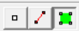
- Viewing the results produces a (Postprocessor) window with several analysis features. Like the drawing modes in the model development window, there are three modes in the analysis (Postprocessor) window, the Point Values mode, the Contour mode and the Block mode, corresponding to the icons, respectively. The Point Values mode provides analysis information at the current pointer location upon a left mouse click. The Contour mode provides parameter variation, such as voltage variation, along a defined contour. The Block mode defines areas and volumes that can be integrated to provide parameters such as total energy.
- From the top menu, select View Density Plot, which opens a dialog box. Check the Show Density Plot and Show Legend in the dialog box.
- From the top menu, select View Vector Plot, which opens a dialog box. Select H for the Vector Plot Type in the dialog box with the Scaling Factor = 1.
- Annotate your name to your simulation results, which is to be done outside of FEMM in an application like Power Point or Word, and then replace Figure 2 below with your version. (7 points.)
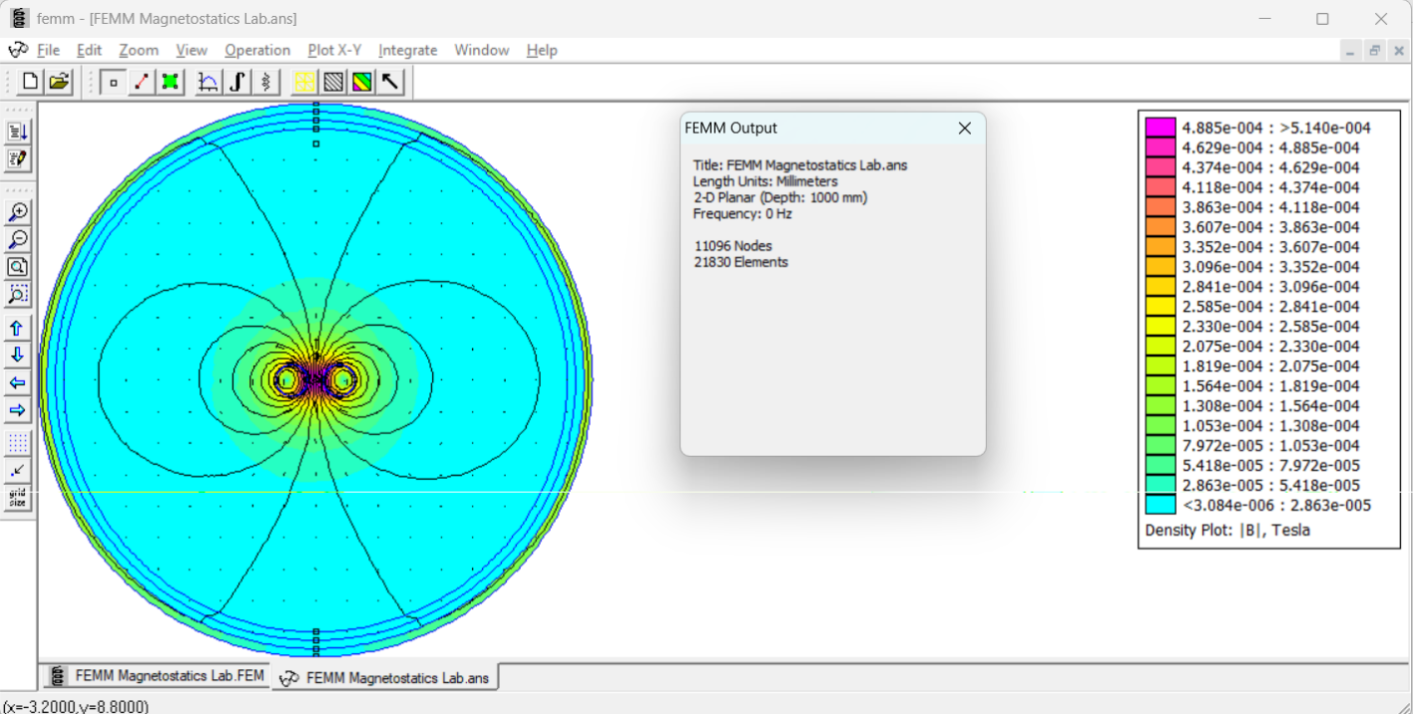
Seth Ricks
Figure 2: Two Adjacent Conductors with Equal and Opposite Directed Current Flow.

Figure 2 illustrates the resulting magnetostatic field for current flowing in the two conductors in the opposite direction, which is often the case for two-wire transmission lines like twisted pair wires. This configuration results in a reduced overall magnetic field because of magnetic field cancellation. However, if the current flows in the same direction in both wires, then there is magnetic field addition rather than magnetic field cancellation.

- Enable the Contour mode from the top toolbar and right mouse click on the center point (node) between the two conductors at location (0, 0) and then move vertically and right mouse click on the node inside the boundary at (0, 7.5) to form a line contour as denoted by a red line between the selected points. (The Escape key removes contour lines as needed.) Select the x-y Plot icon from the top toolbar to open the X-Y Plot of Field Values dialog box. Choose ∣H∣ (Magnitude of field intensity) as the Plot Type and check the Write data to text file option in the dialog box to save the x-y plot data for import into MATLAB. (Note: Do not include spaces in your text file name, as spaces in the filename are incompatible with the MATLAB file read functions.)
- In the geometric model definition window, select Properties Circuits to open the Property Definition dialog box. Choose the Right Wire and click on Modify Property to change the Circuit Current, Amps from -1.0 to 1.0, which is the same as the Left Wire.
- Save your results and then solve the problem again.
- From the top menu, select View Density Plot, which opens a dialog box. Check the Show Density Plot and Show Legend in the dialog box.
- From the top menu, select View Vector Plot, which opens a dialog box. Select H for the Vector Plot Type in the dialog box.
- Annotate your name to your simulation results, which is to be done outside of FEMM in an application like Power Point or Word, and then replace Figure 3 below with your version. (7 points.)
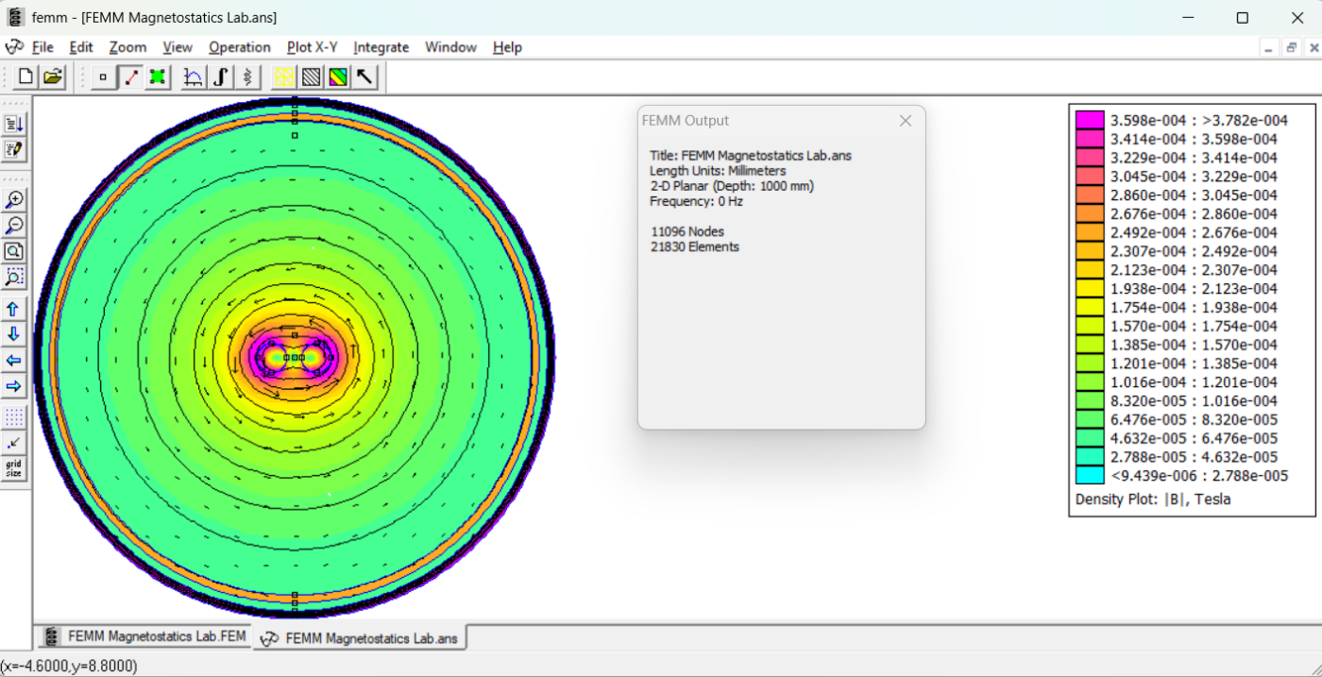
Seth Ricks
Figure 3: Two Adjacent Conductors with Identical Current Flow.

- Enable the Contour mode from the top toolbar and right mouse click on the center point (node) between the two conductors at location (0, 0) and then move vertically and right mouse click on the node inside the boundary at (0, 7.5) to form a line contour as denoted by a red line between the selected points. (The Escape key removes contour lines as needed.) Select the x-y Plot icon from the top toolbar to open the X-Y Plot of Field Values dialog box. Choose ∣H∣ (Magnitude of field intensity) as the Plot Type and check the Write data to text file option in the dialog box to save the x-y plot data for import into MATLAB. (Note: Do not include spaces in your text file name, as spaces in the filename are incompatible with the MATLAB file read functions.)
- Next import your adjacent conductor ∣H∣ data for both opposite and identical conductor current flow into MATLAB and produce a plot of your simulation results as shown below in Figure 4. The MATLAB readmatrix() function, along with appropriate options can read in your saved text files and ignore the first two lines of text header information.

opts = detectImportOptions('Adjacent_Conductor_MagH_for_Opposite_Currents.txt');
opts.DataLines = [3 Inf]; % Start reading from line 3 onward
MagH_opposing = readmatrix('Adjacent_Conductor_MagH_for_Opposite_Currents.txt', opts);

- For your first plot include and x-axis label of “Distance from the Midpoint of Current Carrying Conductors (mm)”, using the xlabel() function. Include a y-axis label of “∣H∣ (A/m)” using the ylabel() function. (See MATLAB help on Greek Letters and Special Characters in Chart Text.) Add a title of “∣H∣ Profile of Two Adjacent Conductors – Your Name”, along with a legend including “Oppositely Directed Currents”, “Identical Currents”, as shown below in Figure 4. (5 Points.)
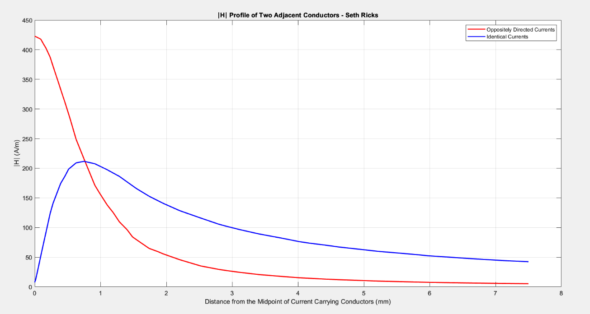
Figure 4: Simulation Results for Two Separated Wires Having the Same Current Magnitude.

Part 2 – Programmable Permanent Magnet

You are to next analyze the Programmable Permanent Magnet circuit illustrated below in Figure 5. For this magnetic circuit, large amplitude current pulses can alter the North-South polarity of a permanent magnet surrounded by the programming coil. The overall magnetic field distribution changes significantly upon changing the North-South polarity of the programming magnet. While the programming coil and current pulse will not be modeled, the resulting magnetic field distribution for the two different North-South pole orientations of the programming magnet will be analyzed.

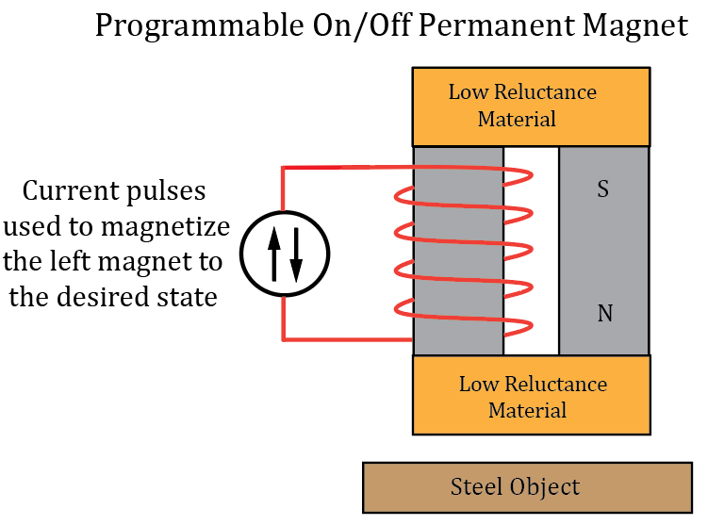
Figure 5: Programmable Permanent Magnet Circuit.

- Select File New Problem and choose Magnetostatics as the Problem Type. Save and name the problem file something like Programmable Permanent Magnet. Select
- Select Problem on the top toolbar to open the Problem Definition dialog box and verify/complete the following settings: Problem Type: Planar, Length Units: Millimeters, Depth: 10, corresponding to 10 mm or 1 cm.
- Select Properties Materials library to open the Materials Library pane to add pre-defined materials to the Model Materials for this project. Right below the Library Materials is Air. Drag the material Air to the Models Material folder in the right-half of the pane.
- Next click on the Hard Magnetic Material Sintered NdFeB Magnets N30 and drag that defined material to the Models Material folder in the right-half of the pane. (Note: NdFeB is Neodymium (Nd), Iron (Fe) and Boron (B), commonly known as a Neodymium magnet. N30 is a grade, indicating the maximum energy product of the magnet.)
- Then click on Soft Magnetic Materials Magnetic Stainless Steel 416 Stainless Steel and drag that defined material to the Models Material folder in the right-half of the pane, which concludes the choosing of materials necessary for this portion of the lab.
- Select the Point (node) drawing mode. The tab key provides an easy way to exactly locate points (nodes) via numeric entry of the x and y coordinates. Enter the following x-y point coordinates using the tab key: (-50, 60), (50, 60), (-50, 30), (-10, 30), (10, 30), (50, 30), (-50, -30), (-10, -30), (10, -30), (50, -30), (-50, -60), (50, -60), (-70, -70),
(70, -70), (-70, -90), (70, -90).
- Select Segment drawing mode.
- Left mouse click on one point (node) then on the next point (node) to join a Line Segments between points (nodes) to produce a 2-D magnetic circuit illustrated below in Figure 6.
- Select the block drawing mode and then left mouse click inside each region and assign the appropriate block types. Also select outside the defined regions and place a block label to define the air region surrounding the structure.
- Right mouse click on each of the 7 block labels followed by pressing the space bar to open the Properties for selected block dialog box to assign the appropriate Block type, which corresponds to a material type previously defined.
- When completed your 7 block types should be assigned the Block types illustrated below in Figure 6.
- Select the left N30 block and press the space bar to open the Properties for selected block dialog box. Change the Magnetization Direction from 0˚ to 90˚.
- Select the right N30 block and press the space bar to open the Properties for selected block dialog box. Change the Magnetization Direction from 0˚ to -90˚.
- Add a Boundary around the wires by clicking on the Boundary icon. In the Open Boundary Builder dialog box set the Layers to 3 and a Radius of 200. Also set/verify the Horizontal and Vertical Center coordinates (0, 0). (Note: If an unexplained error occurs when trying to enter the boundary, saving the file, then closing the FEMM application and reopening the application and file may eliminate the error message.) Your completed geometric model should look like the model shown below in Figure 6.
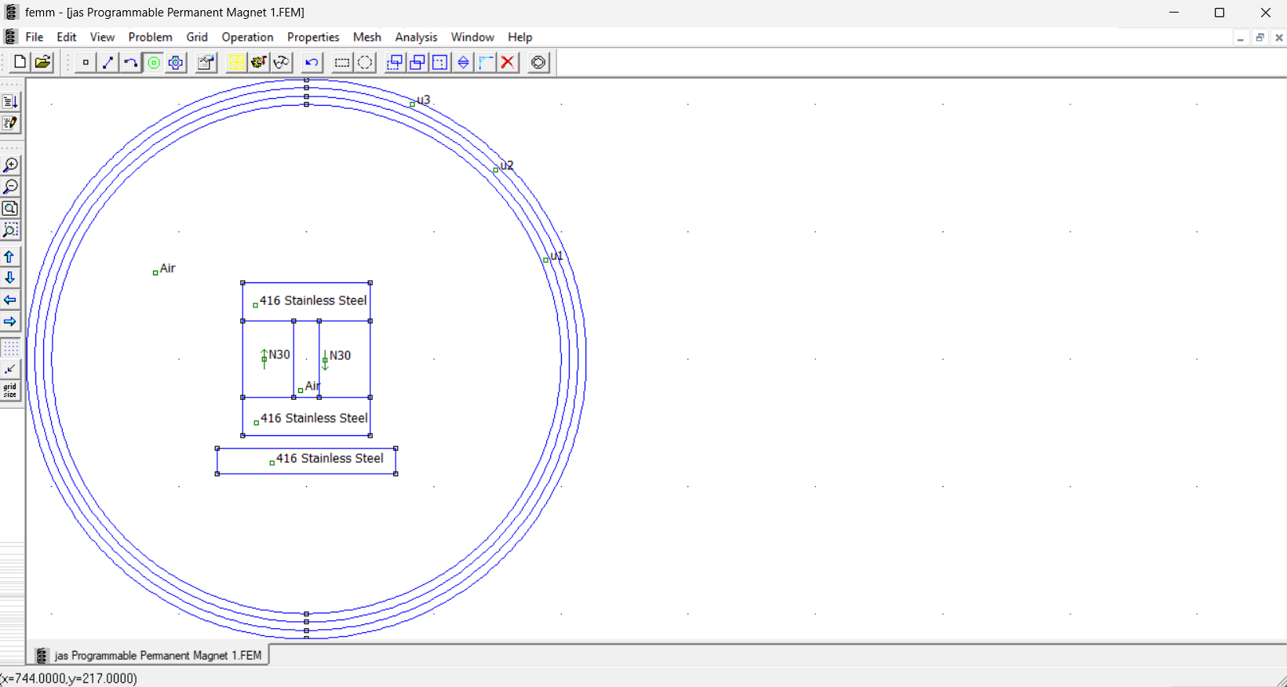
Figure 6: Geometric Model for the Programmable Permanent Magnet.

- Select Mesh Create Mesh, followed by solving the problem followed by Analysis Analyze, and Analysis View Results. Creating the mesh and analyzing the problem and viewing the results can also be accomplished by the icons. (Note: Inadvertently adding extra Block labels is easy to do when clicking around the model development window, which results in the error “Material properties have not been defined for all block labels. Cannot analyze the problem” when trying to simulate your model. One way to find these inadvertent Block labels so they can be deleted is to click on the Zoom extents icon to include all Block labels.)

- Viewing the results produces a (Postprocessor) window with several analysis features. Like the drawing modes in the model development window, there are three modes in the analysis (Postprocessor) window, the Point Values mode, the Contour mode and the Block mode, corresponding to the icons, respectively. The Point Values mode provides analysis information at the current pointer location upon a left mouse click. The Contour mode provides parameter variation, such as voltage variation, along a defined contour. The Block mode defines areas and volumes that can be integrated to provide parameters such as total energy and force.
- From the top menu, select View Density Plot, which opens a dialog box. Check the Show Density Plot and Show Legend in the dialog box.
- From the top menu, select View Vector Plot, which opens a dialog box. Select B for the Vector Plot Type in the dialog box and set the Scaling Factor to 2.
- Annotate your name to your simulation results, which is to be done outside of FEMM in an application like Power Point or Word, and then replace Figure 7 below with your version. (7 points.)
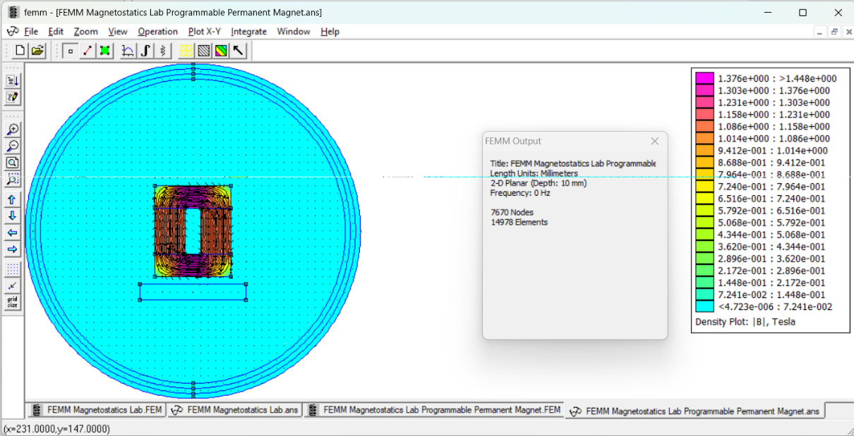
Seth Ricks
Figure 7: Programmable Permanent Magnet Circuit in the Off State.

- In the Postprocessor window select the Block mode and then click inside the steel bar below the structure with the two N30 permanent magnets to highlight that block.
- Select the integral icon which opens the Block Integrals pane. In the dropdown menu select Force via Weighted Stress Tensor and then record the result y-component of the magnetic force on the selected steel bar in Table 1 below for the Off state of the permanent magnet. Include 3 significant figures along with units for your entry. (Note: A tensor represents data having multiple directions or dimensions. A vector is a 1st order tensor, whereas a matrix is a 2nd order tensor.)
- Back in the Geometry window, modify the Magnetization Direction of the left most N30 permanent magnet from 90˚ to -90˚ and re-run the FEA analysis.
- From the top menu, select View Density Plot, which opens a dialog box. Check the Show Density Plot and Show Legend in the dialog box.
- From the top menu, select View Vector Plot, which opens a dialog box. Select B for the Vector Plot Type in the dialog box.
- Annotate your name to your simulation results, which is to be done outside of FEMM in an application like Power Point or Word, and then replace Figure 8 below with your version. (7 points.)
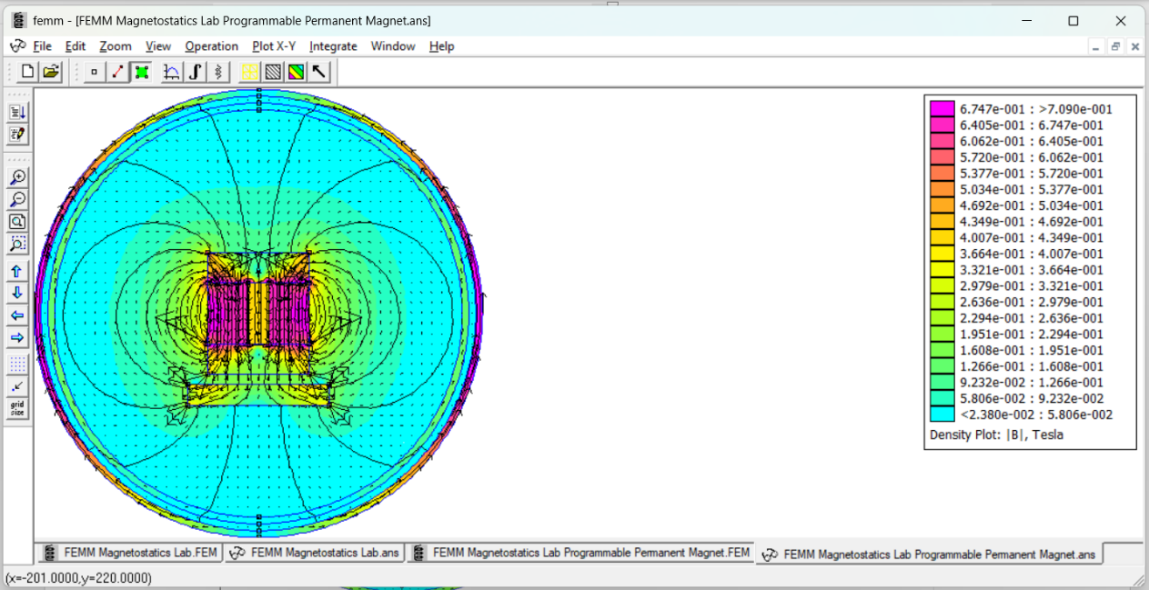
Seth Ricks
Figure 8: Programmable Permanent Magnet Circuit in the On State.

- In the Postprocessor window select the Block mode and then click inside the steel bar below the structure with the two N30 permanent magnets to highlight that block.
- Select the integral icon which opens the Block Integrals pane. In the dropdown menu select Force via Weighted Stress Tensor and then record the result y-component of the magnetic force on the selected steel bar in Table 1 below for the On state of the permanent magnet. Include 3 significant figures along with units for your entry.

Table 1: Simulated Force for the Programmable Permanent Magnet Circuit. (4 points.)
Programmable Permanent Magnet State | F_{y} on Steel Bar
Off | 0.0700188 N
On | 11.7564 N

Discussion and Conclusions Questions: (Note: For the following questions use your own words along with complete sentences. Points are to be deducted for AI generated answers.)

- If you are not familiar with twisted pair wires, research the topic, then describe how Figure 4 illustrates one of the benefits of using twisted pair wires in cables consisting of multiple pairs of wires. (3 points.)
With a twisted pair of wires, the magnetic field lines from one wire cancel out the other. This can be seen in Figure 4, because the further you get from the center of the twisted pair, the smaller the magnetic field intensity.

- The Programmable Permanent Magnet circuit of Figure 5 includes a series magnetic circuit consisting of two permanent magnets, along with adjoining low-reluctance top and bottom plates. Figures 7 and 8 illustrate the resulting magnetostatic fields for two different North-South pole orientations of the leftmost magnet. Describe why the magnetic field lines in Figure 7 are contained within the adjoining ferromagnetic material. Then describe why the magnetic field lines in Figure 8 are not contained within the adjoining ferromagnetic material. (Hint: Magnetic field lines form closed loops following the easiest available path.) (6 points. 3 points for Figure 7 description, 3 points for Figure 8 description.)

Magnetic field lines always follow the easiest path back to the opposite side of the magnet. When the two magnets are oriented in different directions, with N and S on one side, the magnetic field lines can easily flow from the N side of one magnet to the S side of the other. But in the case that they are oriented in the same direction, with N and N on the same side, the field lines can’t go directly from one magnet to the other on the same side. It has to go the long way around, which causes the configuration to attract any magnetic materials.

FEMM Magnetostatics Lab Grading Rubric: Note: This is a CAD lab to be done individually, rather than in teams, although please help each other out if/when opportunities arise, avoiding plagiarism. Submit an electronic version of a lab report to receive credit for doing this lab. The goal of your lab report is to provide sufficient documentation so that others could re-create your results. Therefore, simply add to this document to arrive at your lab report, as all of the explanatory text, procedures and Discussion and Conclusion questions contained in this document are required for a complete lab report. So for your lab report, add a cover page, your results, along with your answers to the Discussion and Conclusions questions to the existing lab document. Your answers to the Discussion and Conclusions questions are to be uniquely yours and not a copy of someone else’s answers to these questions. Your cover page is to include class, lab title, and author. The following rubric does not need to be included in your lab report.
Lab Items | Points
Cover Page | 1
Part 1 – Two Adjacent Conductors  Figure 2: (7 points total. 3 points for correct looking model geometry, 1 point for including colors by means of the Density Plot, 1 point for including contour lines, 1 point for including Magnetic Field Intensity H vector arrows, 1 point for including annotated name.)  Figure 3: (7 points total. 3 points for correct looking model geometry, 1 point for including colors by means of the Density Plot, 1 point for including contour lines, 1 point for including Magnetic Field Intensity H vector arrows, 1 point for including annotated name.)  Figure 4: (5 points total. 1 point for x-axis label, 1 point for y-axis label, 1 point for correct title including name, 1 point for reasonably looking ∣H∣ versus distance trace, 1 point for legend with correct names.) | 19
Part 2 – Programmable On/Off Permanent Magnet  Figure 7: (7 points total. 4 points for correct looking model geometry, 1 point for including colors by means of the Density Plot, 1 point for including Magnetic Field Density B vector arrows, 1 point for including annotated name.)  Figure 8: (7 points total. 4 points for correct looking model geometry, 1 point for including colors by means of the Density Plot, 1 point for including Magnetic Field Density B vector arrows, 1 point for including annotated name.)  Table 1: (4 points total. 2 points per entry, -0.5 points per each missing unit). | 18
Discussion and Conclusions | 9
Grammar and Professionalism | 3
Total | 50
Please give feedback on errors you find in this document.

Part 1.1: Magnetostatics isn’t an option, but magnetics is.
Part 1.6: -0.5 instead of -05.

